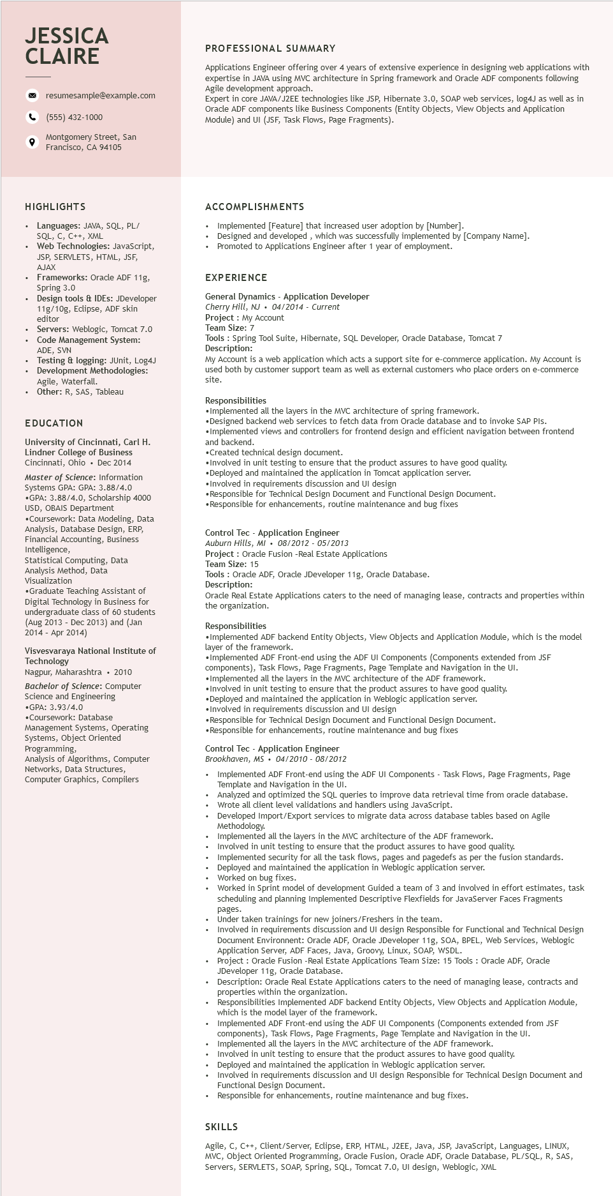
JESSICA CLAIRE
9
resumesample@example.com
(555) 432-1000
Montgomery Street, San Francisco, CA 94105
PROFESSIONAL SUMMARY
Applications Engineer offering over 4 years of extensive experience in designing web applications with expertise in JAVA using MVC architecture in Spring framework and Oracle ADF components following Agile development approach.
Expert in core JAVA/J2EE technologies like JSP, Hibernate 3.0, SOAP web services, log4J as well as in Oracle ADF components like Business Components (Entity Objects, View Objects and Application Module) and UI (JSF, Task Flows, Page Fragments).
HIGHLIGHTS
⚫ Languages: JAVA, SQL, PL/ SQL, C, C++, XML
Web Technologies: JavaScript, JSP, SERVLETS, HTML, JSF, AJAX
Frameworks: Oracle ADF 11g, Spring 3.0
Design tools & IDEs: JDeveloper 11g/10g, Eclipse, ADF skin editor
Servers: Weblogic, Tomcat 7.0 Code Management System: ADE, SVN
Testing & logging: JUnit, Log4J
• Development Methodologies:
·
Agile, Waterfall.
Other: R, SAS, Tableau
EDUCATION
University of Cincinnati, Carl H.
Lindner College of Business Cincinnati, Ohio. Dec 2014 Master of Science: Information Systems GPA: GPA: 3.88/4.0 ⚫GPA: 3.88/4.0, Scholarship 4000 USD, OBAIS Department
•Coursework: Data Modeling, Data Analysis, Database Design, ERP, Analysis, Financial Accounting, Business
Intelligence,
Statistical Computing, Data Analysis Method, Data Visualization
•Graduate Teaching Assistant of Digital Technology in Business for undergraduate class of 60 students (Aug 2013 - Dec 2013) and (Jan 2014 - Apr 2014)
Visvesvaraya National Institute of Technology
Nagpur, Maharashtra ⚫ 2010
Bachelor of Science: Computer Science and Engineering
•GPA: 3.93/4.0 •Coursework: Database
Management Systems, Operating Systems, Object Oriented Programming,
Analysis of Algorithms, Computer Networks, Data Structures, Computer Graphics, Compilers
ACCOMPLISHMENTS
Implemented [Feature] that increased user adoption by [Number].
Designed and developed, which was successfully implemented by [Company Name]. Promoted to Applications Engineer after 1 year of employment.
EXPERIENCE
General Dynamics - Application Developer
Cherry Hill, NJ⚫ 04/2014 - Current
Project: My Account
Team Size: 7
Tools: Spring Tool Suite, Hibernate, SQL Developer, Oracle Database, Tomcat 7 Description:
My Account is a web application which acts a support site for e-commerce application. My Account is used both by customer support team as well as external customers who place orders on e-commerce site.
Responsibilities
•Implemented all the layers in the MVC architecture of spring framework.
•Designed backend web services to fetch data from Oracle database and to invoke SAP PIs. •Implemented views and controllers for frontend design and efficient navigation between frontend and backend.
•Created technical design document.
•Involved in unit testing to ensure that the product assures to have good quality.
•Deployed and maintained the application in Tomcat application server.
•Involved in requirements discussion and UI design
•Responsible for Technical Design Document and Functional Design Document.
•Responsible for enhancements, routine maintenance and bug fixes
Control Tec - Application Engineer
Auburn Hills, MI 08/2012-05/2013
Project: Oracle Fusion -Real Estate Applications
Team Size: 15
Tools: Oracle ADF, Oracle JDeveloper 11g, Oracle Database.
Description:
Oracle Real Estate Applications caters to the need of managing lease, contracts and properties within the organization.
Responsibilities
•Implemented ADF backend Entity Objects, View Objects and Application Module, which is the model layer of the framework.
•Implemented ADF Front-end using the ADF UI Components (Components extended from JSF components), Task Flows, Page Fragments, Page Template and Navigation in the UI.
•Implemented all the layers in the MVC architecture of the ADF framework.
•Involved in unit testing to ensure that the product assures to have good quality.
•Deployed and maintained the application in Weblogic application server.
•Involved in requirements discussion and UI design
•Responsible for Technical Design Document and Functional Design Document. •Responsible for enhancements, routine maintenance and bug fixes
Control Tec - Application Engineer
Brookhaven, MS 04/2010- 08/2012
Implemented ADF Front-end using the ADF UI Components - Task Flows, Page Fragments, Page Template and Navigation in the UI.
Analyzed and optimized the SQL queries to improve data retrieval time from oracle database. Wrote all client level validations and handlers using JavaScript.
Developed Import/Export services to migrate data across database tables based on Agile Methodology.
Implemented all the layers in the MVC architecture of the ADF framework.
Involved in unit testing to ensure that the product assures to have good quality.
Implemented security for all the task flows, pages and pagedefs as per the fusion standards. Deployed and maintained the application in Weblogic application server.
Worked on bug fixes.
Worked in Sprint model of development Guided a team of 3 and involved in effort estimates, task scheduling and planning Implemented Descriptive Flexfields for JavaServer Faces Fragments
pages.
Under taken trainings for new joiners/Freshers in the team.
Involved in requirements discussion and UI design Responsible for Functional and Technical Design Document Environnent: Oracle ADF, Oracle JDeveloper 11g, SOA, BPEL, Web Services, Weblogic Application Server, ADF Faces, Java, Groovy, Linux, SOAP, WSDL.
Project:
t: Oracle Fusion -Real Estate Applications Team Size: 15 Tools: Oracle ADF, Oracle JDeveloper 11g, Oracle Database.
Descr
Oracle Real Estate Applications caters to the need of managing lease, contracts and within the orga organization.
propertion:
Responsibilities Implemented ADF backend Entity Objects, View Objects and Application Module, which is the model layer of the framework.
Implemented ADF Front-end using the ADF UI Components (Components extended from JSF
components), Task Flows, Page Fragments, Page Template and Navigation in the UI.
Implemented all the layers in the MVC architecture of the ADF framework.
Involved in unit testing to ensure that the product assures to have good quality.
Deployed and maintained the application in Weblogic application server.
Involved in requirements discussion and UI design Responsible for Technical Design Document and Functional Design Document.
• Responsible for enhancements, routine maintenance and bug fixes.
SKILLS
Agile, C, C++, Client/Server, Eclipse, ERP, HTML, J2EE, Java, JSP, JavaScript, Languages, LINUX, MVC, Object Oriented Programming, Oracle Fusion, Oracle ADF, Oracle Database, PL/SQL, R, SAS, Servers, SERVLETS, SOAP, Spring, SQL, Tomcat 7.0, UI design, Weblogic, XML

